**Exp.3 LDR interface automatic night lamp**

CIRCUIT DIAGRAM:

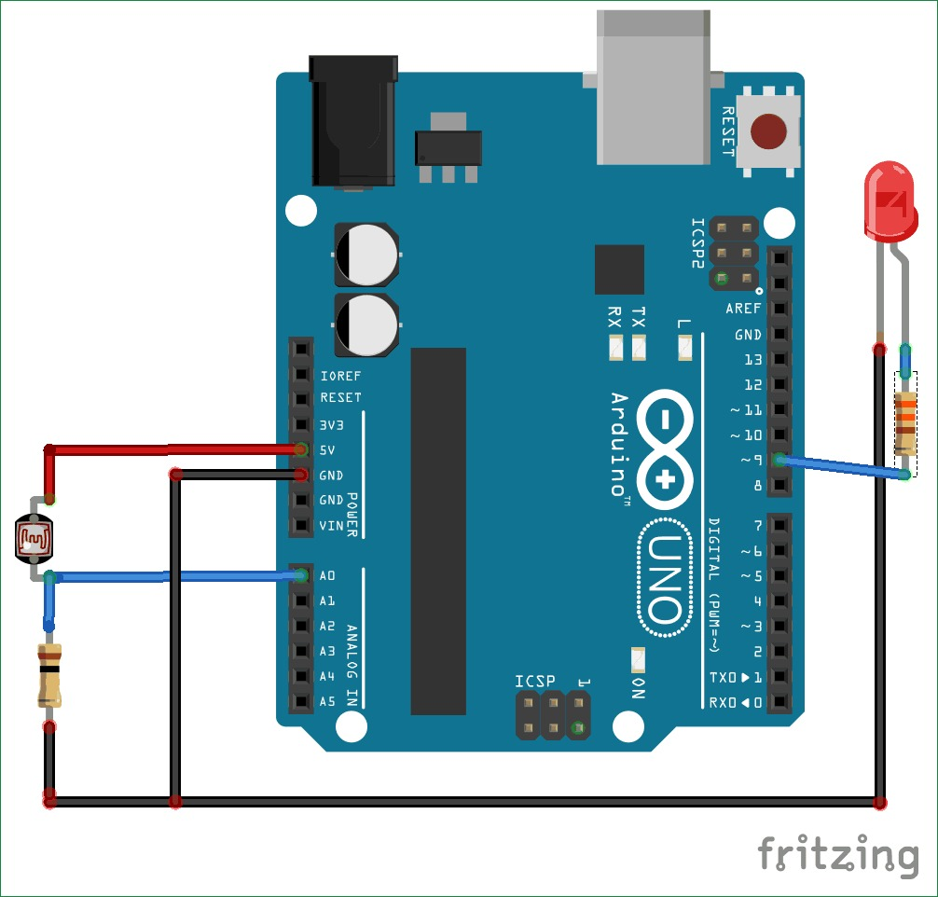

CONCEPT USED:

The LDR is a special type of resistor which allows a lower voltage to pass through it (high resistance) whenever its dark and higher voltages to pass (low resistance) whenever there is a high intensity of light.

CODE:

int LED = 9;

int LDR = A0;

void setup()

{

Serial.begin(9600);

pinMode(LED, OUTPUT);

pinMode(relay, OUTPUT);

pinMode(LDR, INPUT);

}

void loop() {

int LDRValue = analogRead(LDR);

Serial.print("sensor = ");

Serial.print(LDRValue);

if (LDRValue <=700)

{

digitalWrite(LED, HIGH);

digitalWrite(relay, HIGH);

Serial.println("It's Dark Outside; Lights status: ON");

}

else

{

digitalWrite(LED, LOW);

digitalWrite(relay, LOW);

Serial.println("It's Bright Outside; Lights status: OFF");

}

}

Learning and Observations:

In this experiment we learnt the following:

1. Basic circuit building with Arduino uno.

2. Interfacing a LDR sensor with Arduino uno.

Precaution:

1. The LED should not be connected in reversed direction because it doesn’t allow passing the current and circuit does not completed and LED will not glow.

2. The connections should be tight.

Learning Outcomes:

Via this activity we learn and acquire the skills about the following:

1. The application and usage of digital input/output pins of Arduino uno.

2. How LDR sensor work and their interfacing with Arduino Uno.

3. Understood the syntax to write the basic code in Arduino IDE.

4. How to Identify the P-N Junction of LED.